Table of Contents
Login Page 1
Walamoo Tax Page 2
Settings 3
Tax System Information 4
View number of cities by country 5
Tax Information Upload 6
Enter Query 7
Monthly Scenarios 8
Thresholds Settings 9
Reconciliation 10
Registration Form 11
Help Center Page 12

Login Page
Enter your password in this tex box
Enter your username in this text box
This is the welcome screen.

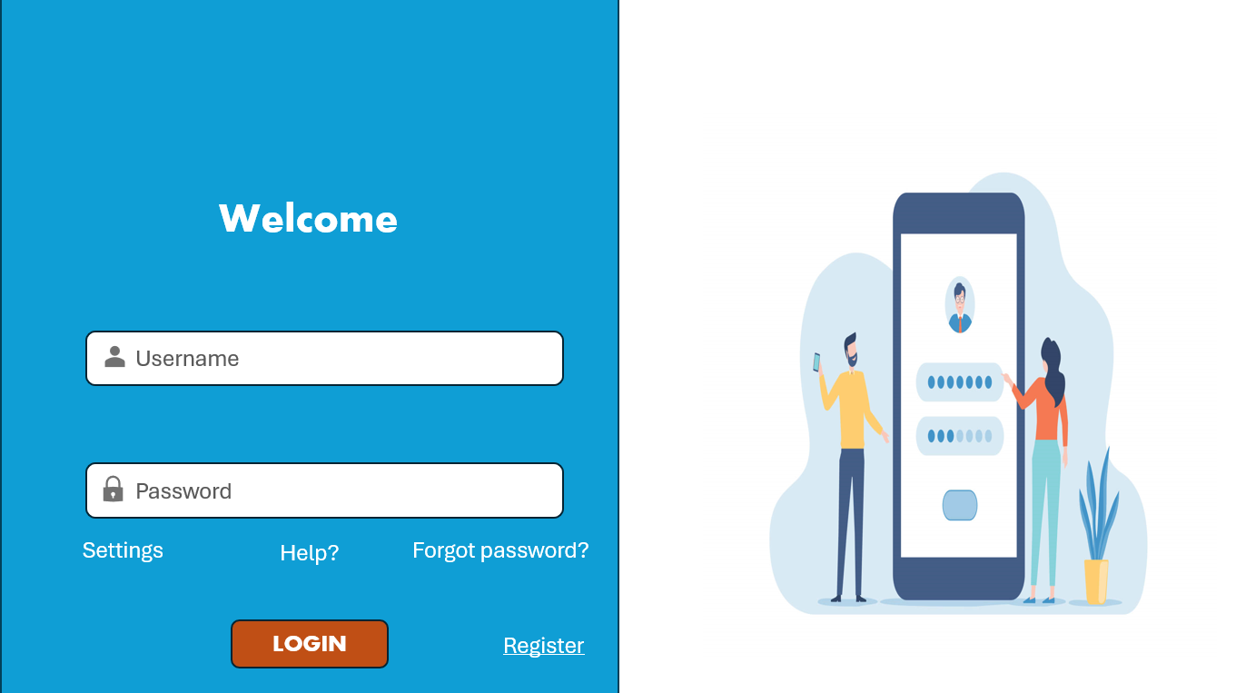
This button will carry you to the forgotten password page
This button will carry you to registration page
This button will carry you to the help page
This button will log you into the Walamoo Tax Page
Button will carry you to the Settings Page

Walamoo Tax Page
This button will give you a search bar.
This button will give a drop down menu to other pages

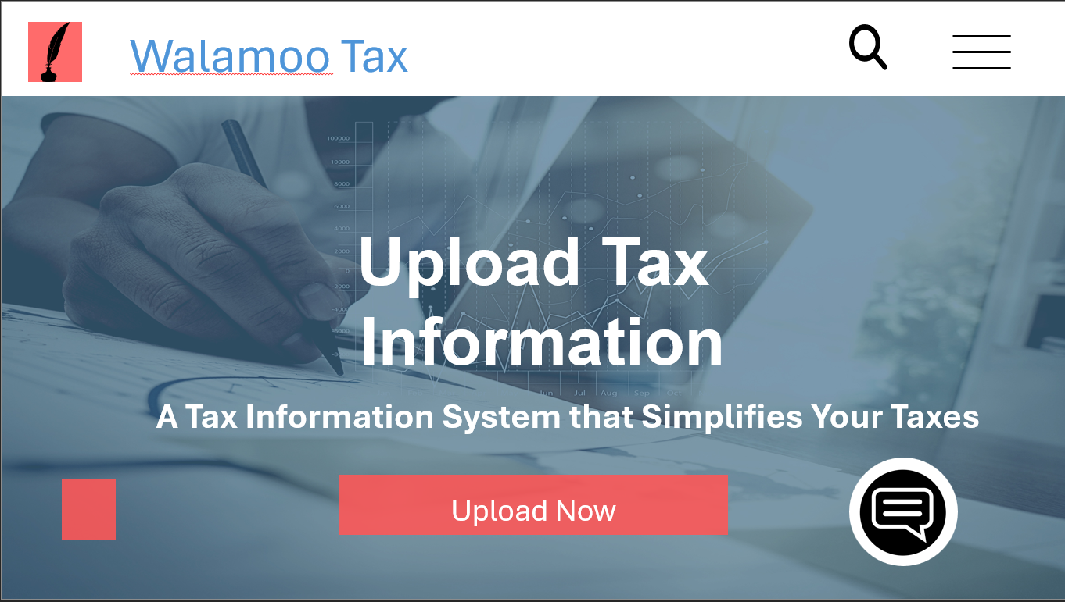
This button will carry you to the tax information upload page
This button will carry you to the Welcome page
This button will carry you to the Help Center page

Settings
This is a drop-down menu to other font style.

This is a drop-down menu to other font size.

This is a drop-down menu to other colors.

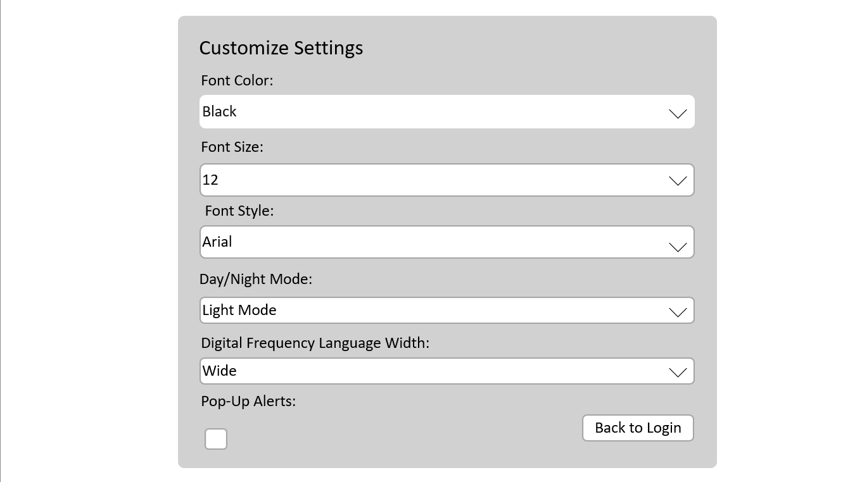
This is a drop-down menu to language width.

This button this check box
This button takes you to login page
This is a drop-down menu to Day and night mode.

Tax System Information

This button will carry you to the Walamoo Tax page

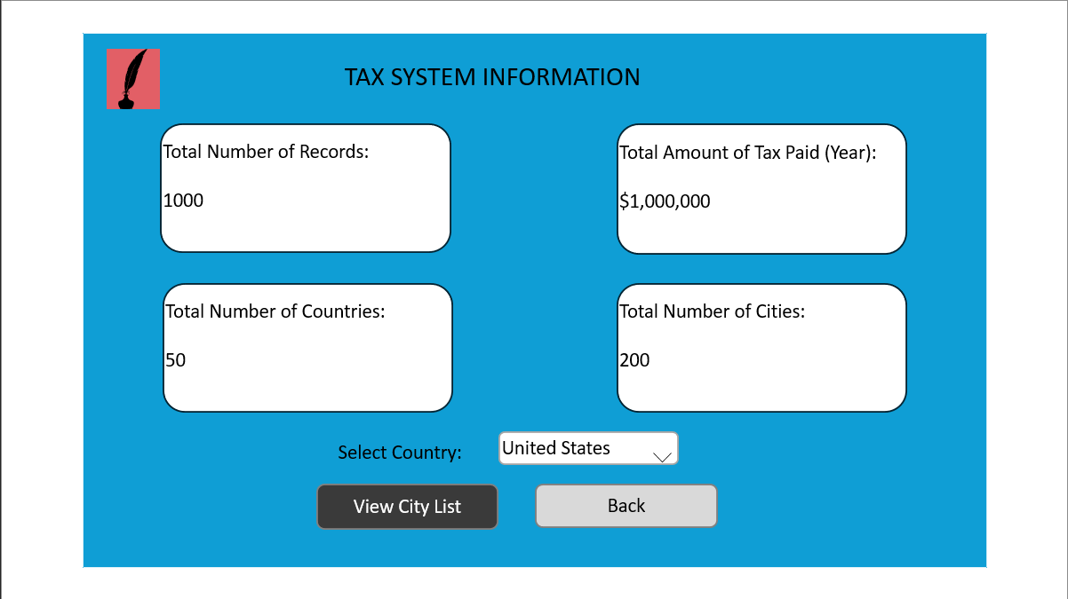
This is a drop-down menu select other countries.

This button carries you back to the walamoo tax page
This button allows you to view the number of cities of a country

View number of cities by country
Information changes base on county selected and the number of cities they have

This button will carry you to the Walamoo Tax page

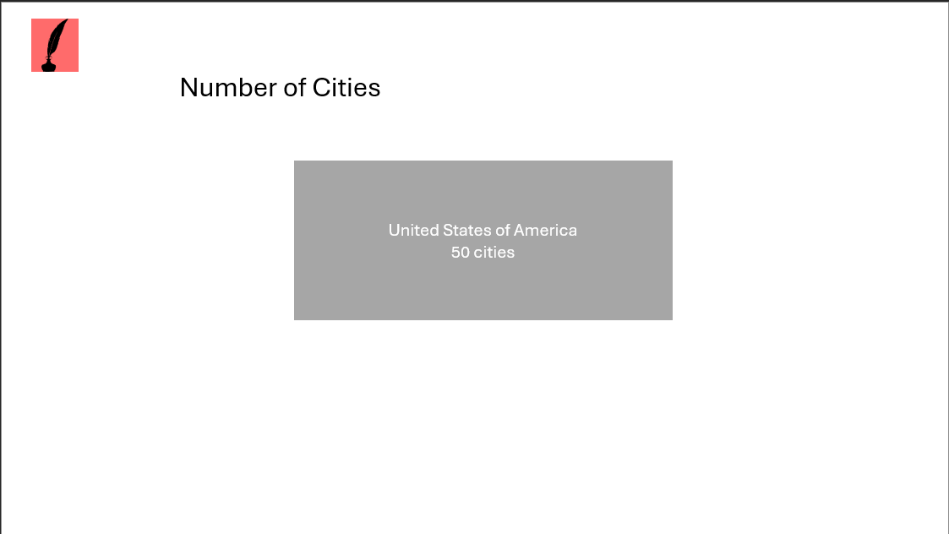

Tax Information Upload
This button will carry you to the Walamoo Tax page

This button will allow you to reupload a XML file

This button will allow you to upload a XML file

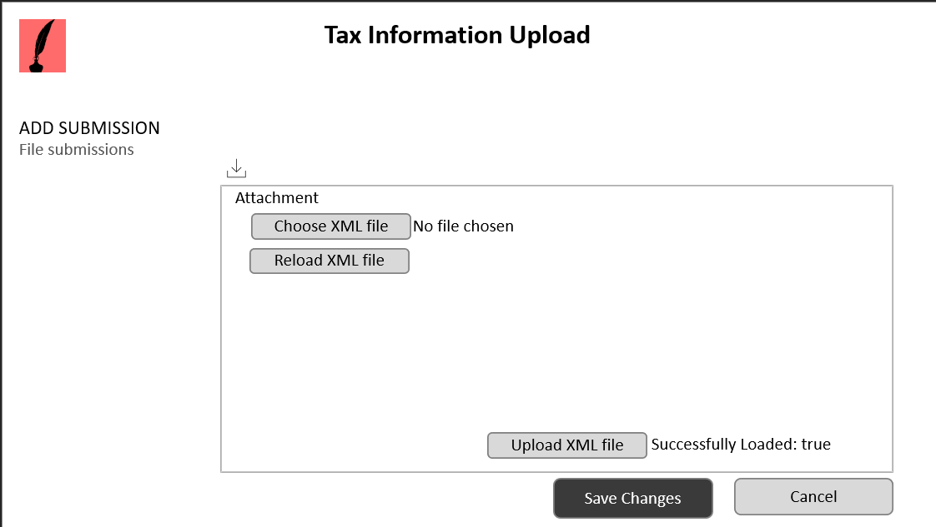
Your able to drag and drop files
This button will allow you to upload a XML file

This button will save the uploaded file

This button will carry you to the Walamoo Tax page

Enter Query
Query results show here
Queries can be entered here
This button will carry you to the Walamoo Tax page

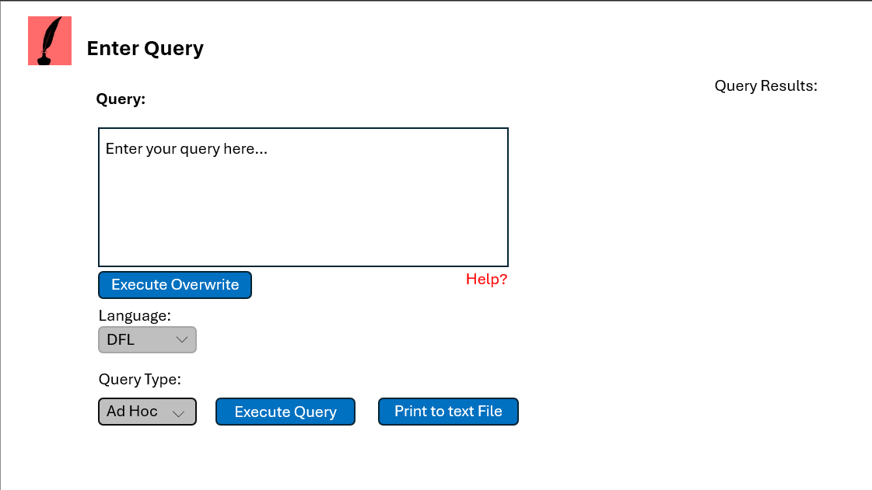
This button forces an execute overwrite

This button will carry you to a help page

This button gives a drop-down menu select of Language types

This button gives a drop-down menu select of other Query types

This button executes the query

This button prints query to a text file

Monthly Scenarios
This button gives a drop-down menu select of the months

This button will carry you to the Walamoo Tax page

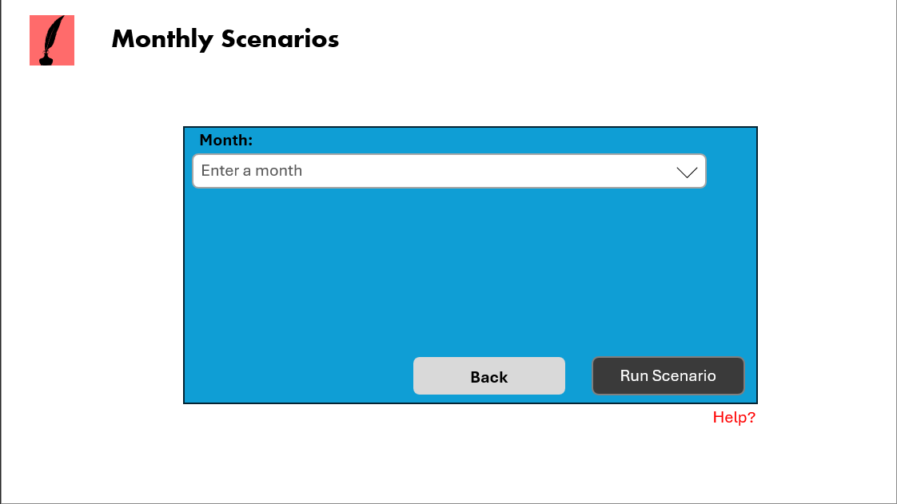
This button will carry you back to????

This button run the Scenario

This button will carry you to a help page

Thresholds Settings
This button will carry you to the Walamoo Tax page

Text box to enter the Thresholds value
This button gives a drop-down menu select of minimum tax

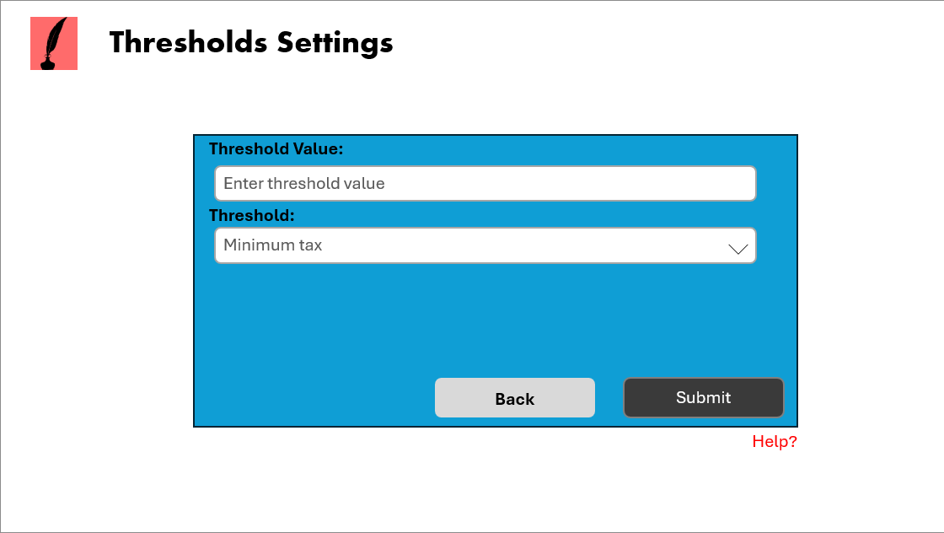
This button submits the threshold value and minimum tax

This button will carry you back to????

This button will carry you to a help page

Reconciliation
This button will carry you to the Walamoo Tax page

Difference between total taxes paid show here
Text box to enter the Deposit value

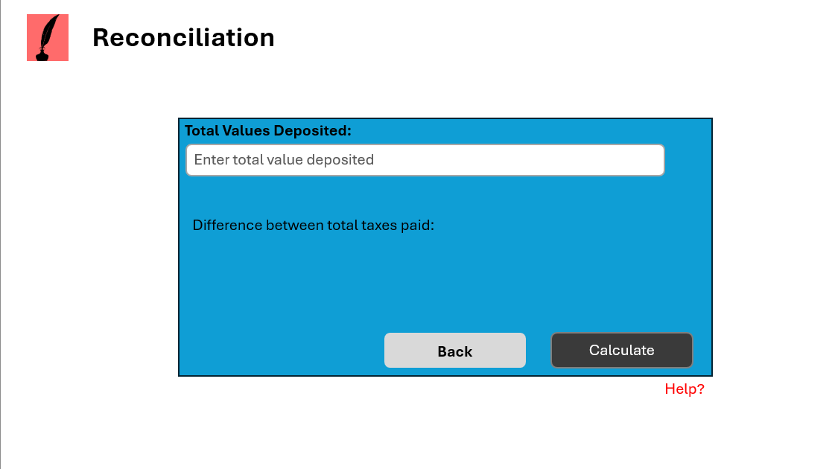
This button will carry out calculations

This button will carry you back to????

This button will carry you to a help page

Registration Form

Text box to enter the Last Name
Text box to enter the First Name

This button will carry you to the Walamoo Tax page

Text box to enter the Last Name
Text box to enter your Country

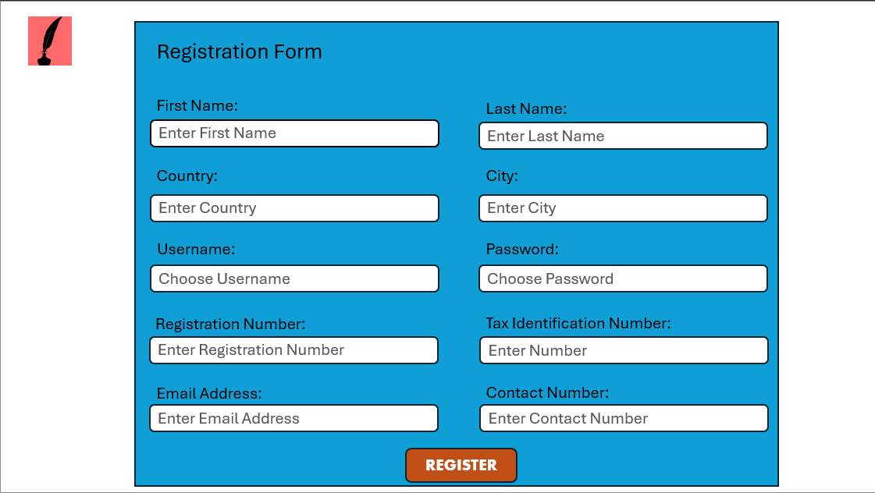
Text box to enter the Last Name
Text box to enter the Last Name
Text box to enter the Email Address

Text box to enter the Contact number

Text box to enter the Registration number
Text box to enter the Tax Identification Number
This button will register users

Help Center Page
This button will carry you to the Walamoo Tax page

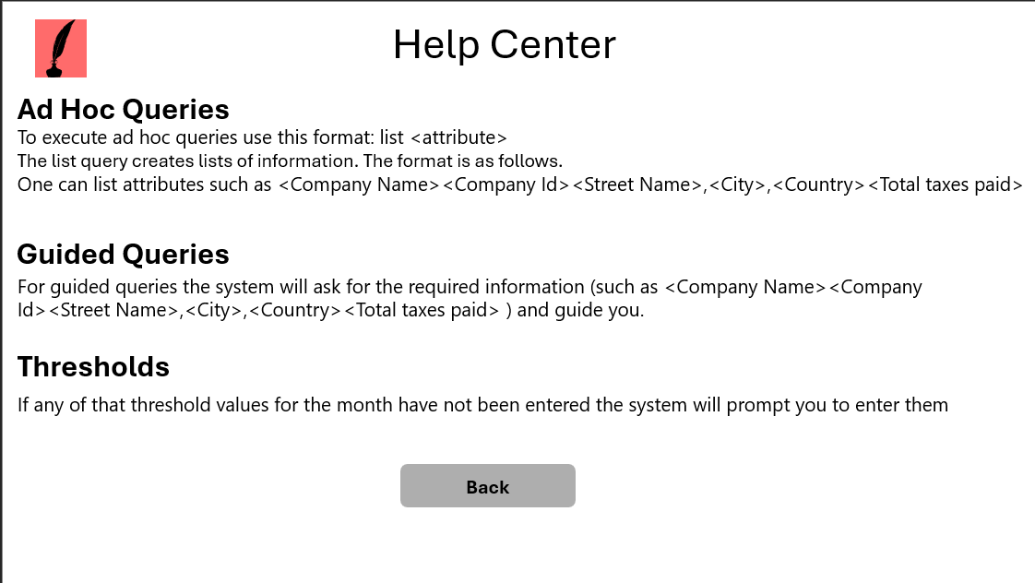
Returns you to previous page

